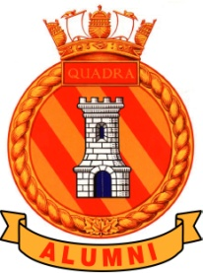
The Alumni Association of HMCS Quadra
with
The Wardroom of HMCS Quadra
Celebrates
The 60th Anniversary of HMCS Quadra
With a Dinner and Dance
At the Florence Filberg Center
411 Anderton Avenue
Cocktails at 1800 hrs

Dinner at 1900 hrs

Dancing after Dinner

Buffet Menu

Roast Prime Rib of Beef
Vodka Peppercorn Salmon
Roasted Potatoes
Mixed Vegetables
A Trio of Salads
Dinner Rolls
A selection of Fruit
An assortment of Squares

$55.00

No Host Bar by the Courtenay Rotary Club

